**SPRING PENDULUM**

**RESEARCH QUESTION:**

~~To what extent the length of spring pendulum affects its time period if the density of the material of the spring number of turns per unit length and diameter of spring are kept constant.~~

To what extent time period of a block of mass, m, suspended from a brass spring depends on the mass of the block attached with it if the mass of spring is constant but not negligible, and amplitude of oscillation and air resistance is negligible.

**INTRODUCTION:**

The spring is a sensation of human engineering and innovativeness. For one, it comes in such a significant number of assortments –the compression spring, the extension spring, the torsion spring, the coil spring, and so on – all of which serve unique and explicit functions. These functions thusly take into account the making of many man-made objects, the vast majority of which rose as a feature of the Scientific Revolution amid the late 17th and 18th centuries.

From a very small age, I was really interested in objects having springs; whether it was a part of a toy or a pen, I would take it out and fiddle with it. As I grew up, I started observing and investigating further uses of springs and reached at a time now where we have performed experiments using spring in the physics lab, for example, investigating Hooke’s law. Further I started exploring other variables that are kept in consideration while performing experiments using springs. I studied that the time period of spring depends on a lot of factors. When performing an experiment with a spring to either investigate Hooke’s law or to demonstrate SHM, the length of the spring and the mass due to it has been ignored. When I performed an experiment regarding the spring pendulum to find the time period with hanging mass of 140g, my results from the practical didn’t match the theory as per the formula, . This made me research more into the concept of spring pendulum and the factors that might affect its time period of oscillation. With research, I got to know that the mass of spring is also a factor that affects the time period. The theoretical formula, , does not consider the mass of the spring and that is the reason my experimental result differed from the theoretical result. Therefore, I wanted to investigate further, and decided to perform this by changing the mass of the hanging bob – keeping the mass of spring constant – and finding the changes in the time period.

**HISTORY AND BACKGROUND:**

Galileo Galilei, an Italian scientist, was the first to study the properties of a pendulum, starting around 1602. Around 1602, he studied pendulum properties after observing a swinging lamp in the cathedral of Pisa's domed ceiling. He initiated that the period is independent of the mass of the bob, and proportional to the square root of the length of a pendulum. Pendulum was the first oscillator of real technological importance. In spite of the fact that Galileo and his son had the idea of a pendulum clock in 1637, however, never lived to finish it. Further in 1656, a Dutch Scientist, Christiaan Huygens made the principal pendulum clock regulated by a mechanism with a ‘natural’ period of oscillation. Till the 1930s, the pendulum clock was said to be the world's most precise timekeeper.

The pendulum clock was having a variation in time due to variation in gravitational acceleration and hence, the idea of a spring-based clock was originated. Further, the use of elastic spring helped to overcome the problem.

Hooke’s law, the law of elasticity, is named after the 17th century British physicist Robert Hooke, who looked to exhibit the connection between the forces applied to a spring and its elasticity.

Spring balance also has a similar concept where restoring force of spring is used to measure unknown mass with the help of a calibrated scale, that is, calibrated for applied mass with its extension.

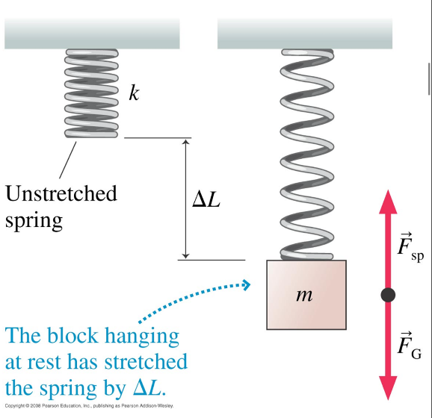SPRING PENDULUM:

VERTICAL OSCILLATIONS

* At equilibrium (no net force), spring is stretched (cf. horizontal spring): spring force balances gravity.
* Hooke’s law: (Fsp)y =−k∆y =+ k∆L
* Newton’s law: (Fnet)y =(Fsp)y +(FG)y = k∆L−mg =0 ⇒∆L = mg/k

Figure 1

* 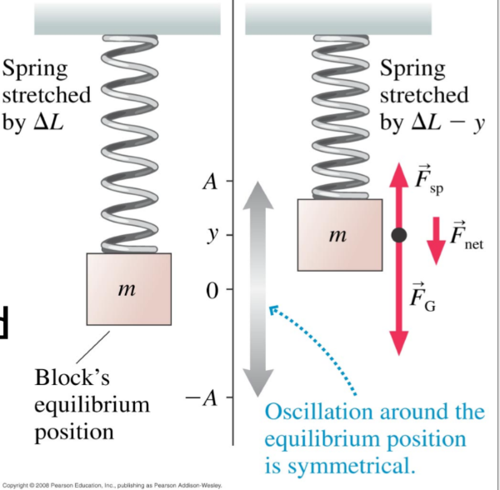oscillation around equilibrium, y=0 (spring stretched), block moves upwards, spring still stretched.

Figure

* (Fnet)y =(Fsp)y +(FG)y = k(∆L−y)−mg

Using k∆L−mg = 0 (equilibrium), (Fnet)y =−ky

Gravity “disappeared” as before: 

**HYPOTHESIS:**

IDEAL FORMULA



The ideal formula given is not accurate as the mass of the spring varying with the length is considered to be 0. As mentioned earlier above, the mass of the spring in terms of its length has to be considered as this may result in a different time period which would be more faultless. Hence, I will be deriving a formula to get a more accurate time period by considering the mass of the spring in terms of its length. The formula I will be deriving is: -



Suppose spring has a finite mass ms,

Instantaneous K.E of the whole spring :-



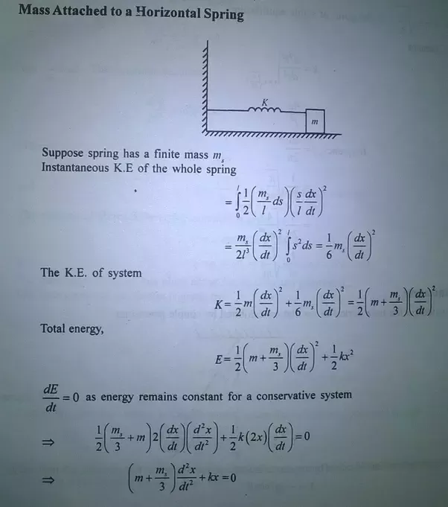

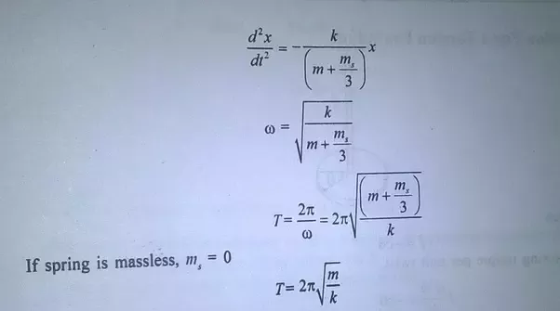

The equation form of the formula,  , is derived to be:





So, for constant value of , has linear dependency on slotted mass () for constant value of .

Hence, a graph for against must be a straight line with constant slope, 

**SELECTION OF VARIABLES:-**

As per the formula derived in my hypothesis, the **time period (T)** of the spring pendulum is varying with change in **mass (m)** of the slotted mass. Therefore, my independent variable is **mass (m)** of the slotted mass. My dependent variable is the square of **time period** of the spring pendulum that is varying with the change in **mass** of the slotted mass; greater the **mass** of the slotted mass, greater the **time period**.

I would consider the **density** of the spring’s material, **diameter** of the spring, and **mass** of the spring as controlled variables as they are constant. The density of the spring will be kept constant as same spring will be used which is made of steel. The diameter of the spring will be measured by the ruler. The **total length per unit** of the spring pendulum would also be kept constant, that is, __. I would also control the **thickness of the spring’s wire** as this could affect the stretching of the spring. This would be constant for the spring and I will measure it with the help of a Vernier caliper. Gravity does affect the period of a pendulum. The **gravitational force** on the pendulum mass is constant and independent of displacement and therefore, the gravitational acceleration would be constant, that is, 9.81m/s2. I have to also make sure that the spring is stretched under the spring’s **elastic limit** as this could affect the oscillation of the spring pendulum and give inaccurate data. The surrounding **temperature** should also be kept constant (room temperature) as the temperature could result changes in the physical properties of the spring; in this case, the expansion of the spring.

**APPARATUS:-**

|  |  |  |  |  |
| --- | --- | --- | --- | --- |
| S. NO. | APPARATUS | QUANTITY | SPECIFICATIONS | USE |
| 1 | Clamp Stand | 1 | 62 cm tall | Used to hang the spring when oscillating |
| 2 | Spring | 1 | 11.8cm, 130 turns, 36.4 grams | Vertical spring pendulum |
| 3 | Slotted mass  with hanger | 5 | 20g, 40g, 60g, 80g, 100g, 120g, 140g | To hang it to the bottom of the spring and check the oscillation. |
| 4 | Stop watch | 1 | Least count (s) | To measure the time taken in seconds for completing 10  oscillations. |
| 5 | Ruler | 1 | 100 cm | To measure the distance when pulling the spring to make it oscillate. |

**PROCEDURE: -**

A stand was stationed on a stable platform in the lab. I took the 11.8cm unstretched spring and attached it to the top of the stand. The mass of the 11.8cm spring, made up of steel, was 36.4g and had 130 turns. I took slotted masses and hung it below the spring. I decided to check the time period of 10 oscillations using different mass of the slotted mass, but constant weight of the spring and the same amount of distance pulled before releasing the spring to make it oscillate. For making sure that I pulled the same amount of distance before releasing, I used a 100cm ruler, and pulled the spring for 10cm. First, I checked the time period for 10 oscillations using 140g of slotted mass. I pulled the spring 10cm from below and released it so that it could oscillate. I kept a check on the time period using a stopwatch. I stopped the running time once the 10 oscillations were completed. Further, I performed the same steps using different masses of slotted mass: 20g, 40g, 60g, 80g, 100g, 120g, 140g. Once I was done with all the masses mentioned, I noticed that as the mass of the slotted mass increased, keeping the mass of the spring same, the time period of 10 oscillations had also increased. By using the same spring, I made sure that the material of the spring is the same and the density of the spring is constant. After performing the experiment for all the number of masses, I used the value of the time period, the mass of the spring, and the mass of the spring to find the constant, , that is mentioned in the formula I had derived in the hypothesis, .

**DATA ANALYSIS: -**

Following the methods mentioned in the procedure, I had carried out the experiment and obtained the subsequent results in the table below. The hanging mass, that is 0.14 kg, will be kept constant.

|  |  |  |  |  |  |  |  |  |  |  |  |  |  |
| --- | --- | --- | --- | --- | --- | --- | --- | --- | --- | --- | --- | --- | --- |
| **S.No.** | **MASS**  **(**kg**)/**  of slotted mass | **TIME (**s**)/** t  **(**for  20 Oscillations**)**  3 Trials | | | **Average of 3 trials(**s**)/**  tavg | **∆t** | **Time for one oscillation (**s**)/ T** | | | **Tavg. (**s**)** | **∆T** | **(Tavg)2** | **∆ T2**  **2T∆T** |
| 1 | 0.02 | 6.45 | 5.93 | 7.14 | 6.51 | 0.605 | 0.326 | 0.297 | 0.357 | 0.327 |  | 0.107 |  |
| 2 | 0.04 | 7.64 | 8.97 | 8.31 | 8.31 | 0.665 | 0.382 | 0.449 | 0.416 | 0.416 |  | 0.173 |  |
| 3 | 0.06 | 9.79 | 10.36 | 9.03 | 9.73 | 0.665 | 0.490 | 0.518 | 0.452 | 0.487 |  | 0.237 |  |
| 4 | 0.08 | 10.34 | 11.03 | 11.57 | 10.98 | 0.615 | 0.517 | 0.552 | 0.579 | 0.549 |  | 0.302 |  |
| 5 | 0.10 | 12.81 | 11.53 | 12.18 | 12.17 | 0.640 | 0.641 | 0.577 | 0.609 | 0.609 |  | 0.371 |  |
| 6 | 0.12 | 12.66 | 13.22 | 13.87 | 13.25 | 0.605 | 0.633 | 0.661 | 0.694 | 0.663 |  | 0.439 |  |
| 7 | 0.14 | 14.72 | 13.51 | 14.15 | 14.13 | 0.605 | 0.736 | 0.676 | 0.708 | 0.707 |  | 0.499 |  |